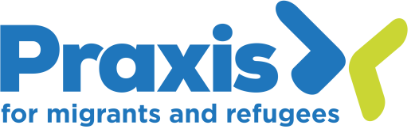
Social media volunteer

About us: Praxis is a dynamic, award-winning human rights charity supporting people who have migrated who are in crisis or at-risk, ensuring that their essential human needs are met and that they are able to overcome the barriers they face. We provide legal advice and holistic support including group work. We build community, challenge exclusion and discrimination, influence policy, improve services and inspire solidarity with those who have migrated. Praxis actively builds communities of support to campaign and advocate for systemic change to end discrimination towards people who have migrated.

Purpose of the role:

We are looking for a dedicated volunteer to support us with social media content and monitoring.

Over the past year, Praxis has been implementing a digital mobilization framework to build public support and action for our vision. As part of this work, producing engaging social media content is key. The volunteer would be creating social media content in accordance with our social media strategy, tone of voice, and the wider digital mobilization framework.

Tasks will include:

- Writing and scheduling social media content to communicate our work, impact, and to further our public campaigns.
- Forefront stories of people with lived experience and Praxis community members within the content.
- Monitor and report on social media growth.
- If interested, write short form content for the website or design graphics for petition webpages.

Opportunities to:

- Gain experience in content production and content management.
- Learn about social media strategy and building public engagement through digital platforms.
- Learn about messaging and framing.
- Training on Canva and Later (social media scheduling platform).
- Gain experience with UTM tracking and monitoring and reporting practices.

Role requirements:

- An interest and experience in social media
- An interest in campaigning and digital mobilization
- An interest in human rights and migration issues.
- Alignment with Praxis’ values

Terms

We would welcome someone who can dedicate 1 day a week to this role, for a minimum of three months, but we are open to accommodate other patterns.

Activities will be undertaken remotely or at our offices in Bethnal Green. Ongoing supervision, support and in-house training will be provided.

We are an equal opportunity organisation and strongly encourage applications from those with lived experience of migration, and from diverse applicants regardless of age, disability, gender reassignment, marital/civil partnership status, race, religion or belief, sex, sexual orientation, or pregnancy/maternity leave status.

To apply please complete a volunteer application form.

If the volunteer application form is not accessible for you please contact our Volunteer Coordinator by email (teya.cooper@praxis.org.uk) or phone (07862001693).

